Information about the

Māori Electoral Option –
Te Kōwhiringa Pōti for the Tauranga City Council election
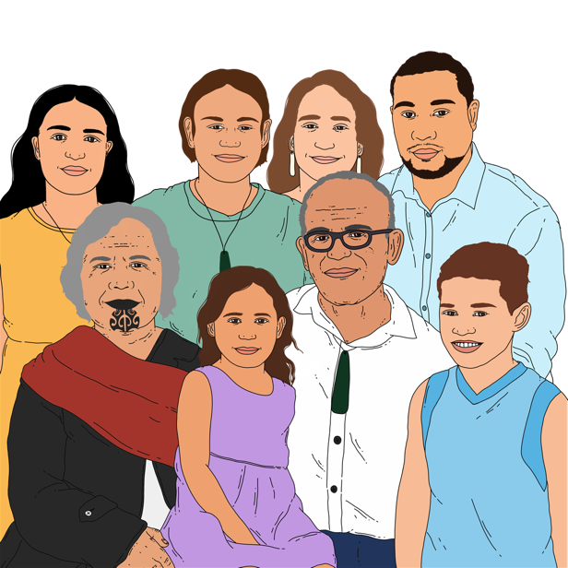
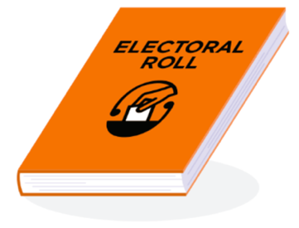

Updated: April 2024

Before you read this document

This Easy Read document talks about things to do with elections in New Zealand.

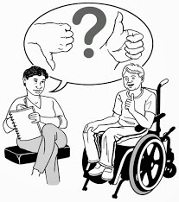
An election is the time when you can vote for the people you want to make important decisions about:
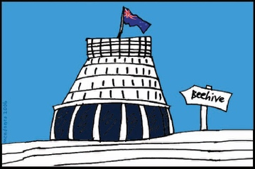
- things that affect how you live
- the country you live in.

While this document is written in Easy Read it uses some hard words which you might not know.

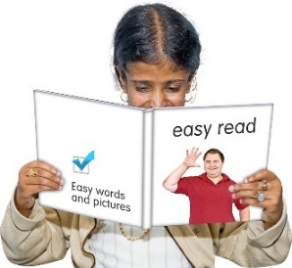
Some things you can do to make it easier are:
- read a few pages at a time
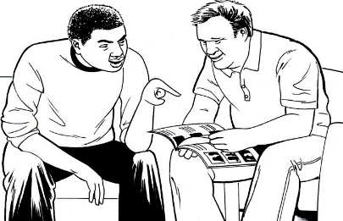
- have someone support you to understand it.

What you will find in here

Page number:

What is this document about? 4

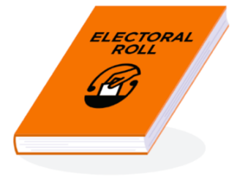
What are the electoral rolls? 7

What is the local council ward? 12

Voting in the Tauranga City
Council election 15

How to change which roll you
are on 17

Where to find more information 21

What is this document about?

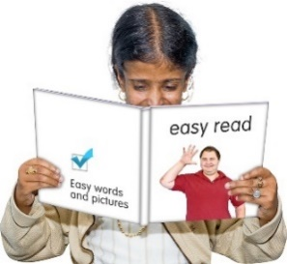
This Easy Read document is from the Electoral Commission about the Māori Electoral Option –
Te Kōwhiringa Pōti Māori for the Tauranga City Council election.

The Electoral Commission works to keep the electoral rolls up to date.

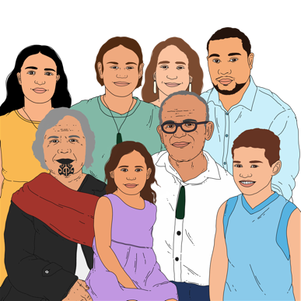
The Māori Electoral Option is a choice for Māori about which electoral roll they want to be on.

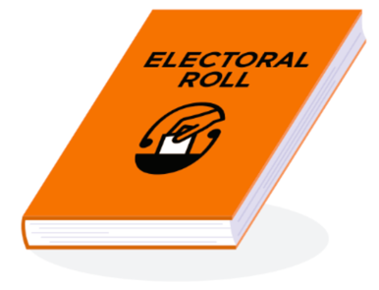
The electoral roll is a list of all the people in New Zealand who have enrolled to vote.

Being enrolled to vote means:
- your name is on the electoral roll
- you can vote in an election.

When you vote you get to have your say about who you think should win an election.

An election is the time when you can vote for the people you want to make important decisions about:
- things that affect how you live
- the country you live in.

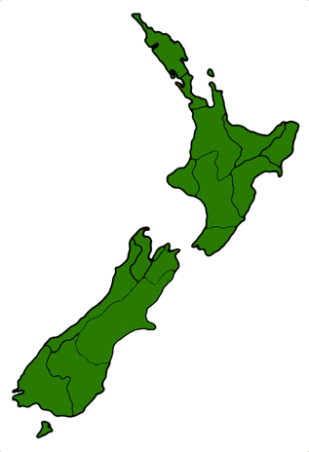
Tauranga City Council is an area on the North Island of Aotearoa New Zealand.

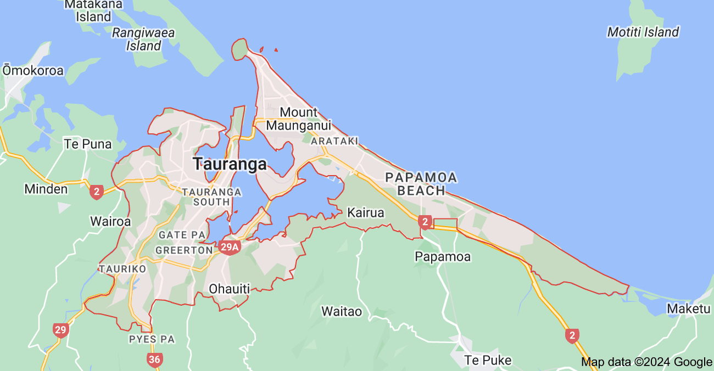

What are the electoral rolls?

The electoral roll is split into 2 lists:
- the Māori roll that is open to voters who are Māori
- the general roll that is open to all voters.

No one can be on both rolls at the same time.

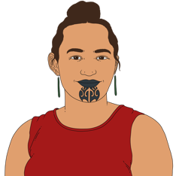
You can choose which electoral roll you want to be on if you are Māori.

The information in this document tells you about changes you can make once you are already enrolled to vote like:
- how you can change which electoral roll you are on
- when you can change which electoral roll you are on.

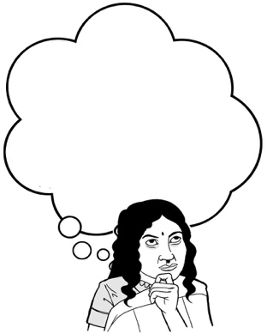
The information in this document can support people to make their choice about which electoral roll they want to be on.

It is a good idea to share the information in this document with people you know who are not yet enrolled to vote.

To get enrolled to vote in New Zealand you must:
18

- be at least 18 years old

and

- have lived in New Zealand for more than 1 year at some time in your life

and
- be:

- a New Zealand citizen
or

- a New Zealand permanent resident.

A New Zealand citizen is someone who can get a New Zealand passport.
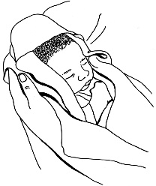

Most New Zealand citizens were born in New Zealand.

A New Zealand permanent resident is someone who:

- is not a New Zealand Citizen.
- has been told by the government they can live in New Zealand all the time.

The electoral roll you choose to be on changes which candidates you can vote for in elections.

You can change your roll type at any time except in the 3 months before a local election happens.
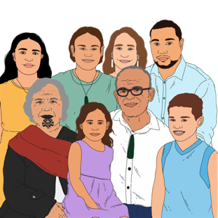

You can only change which electoral roll you are on if you are Māori.

What is a local council ward?

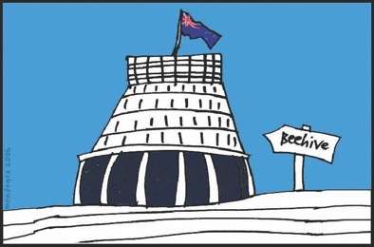
Local government is separate from central Government.

Local government in New Zealand is made up of:
regional councils
city councils.
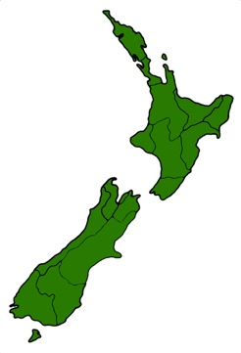

Regional councils look after large areas of land called regions.

City councils look after the cities in New Zealand.

City councils have voting areas called wards.

A ward might be your:
- suburb
- town
- city
- area in the countryside.

These wards:
- are not always the same size

but
- they usually have around the same number of people in them.

The Tauranga City Council has both:
a Māori ward
and
8 general wards.

In a local election you vote for people called councillors who will represent the people in each ward.

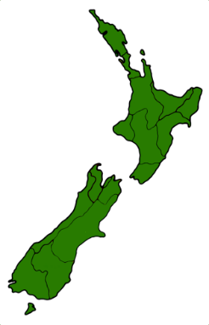
A local election is when people vote for who they want to be part of the councils in the place they live.

Voting in the Tauranga City Council election

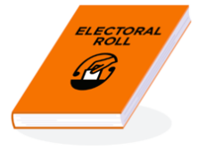
In the Tauranga City Council election you will vote for candidates in a Māori ward if you choose to be on the Māori electoral roll.

If you choose to be on the general electoral roll you will vote for candidates in the general wards.

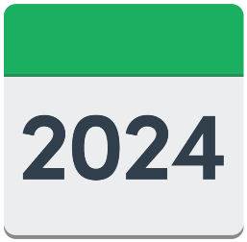
The Tauranga City Council election is on 20 July 2024 to choose:
- new councillors
- a mayor.

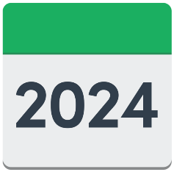
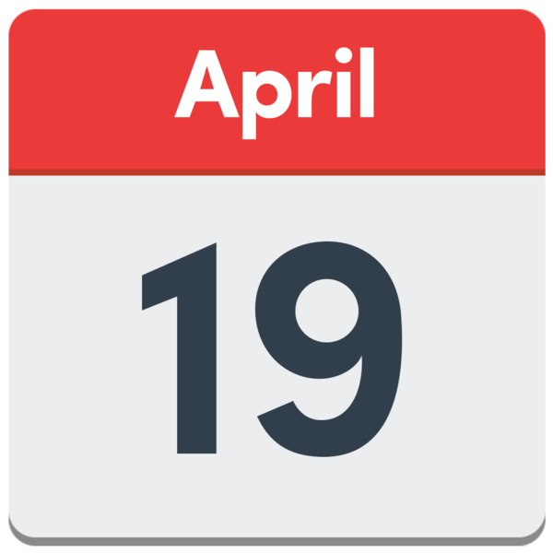
You have until midnight 19 April 2024 to change your roll type if you are:
- Māori
- already enrolled to vote in the Tauranga City Council election.

You will choose which electoral roll you want to be on when you enrol if you are:
- Māori
- enrolling for the first time.

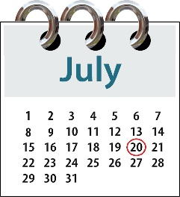
Which roll you are on means which candidates you can choose from in the Tauranga City Council election on 20 July 2024.

How to change which roll you are on

If you are happy with the electoral roll you are on you do not need to do anything.

You can change which electoral roll you are on by:
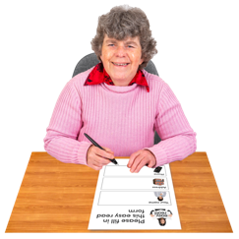
- going to the website at:
vote.nz
- filling in a paper enrolment form and sending it back to us.

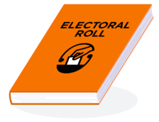
You can also enrol to vote for the first time.

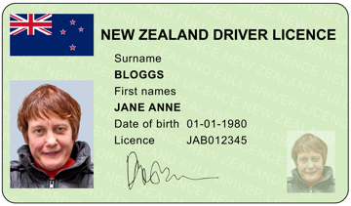
If you choose to change your electoral roll online you must have a form of ID like:
- a New Zealand driver licence
- a New Zealand passport
- a RealMe verified identity.

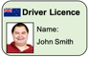
A form of ID is an official document that you can use to prove who you are.

Verified means something that has been checked to make sure it is true.

We can also send you a paper enrolment form by post.

You can call us to ask us to send you a paper enrolment form on:

0800 36 76 56
It will not cost you any money to call this number.

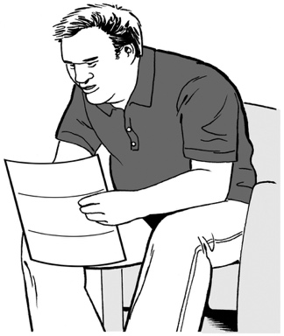
Some Māori who are already enrolled to vote have been sent an information pack by post about the Māori Electoral Option.

You can change which electoral roll you are on by sending us the letter that is in the information pack.

Before you send the letter to us make sure you:
- sign it
- put the date on it.

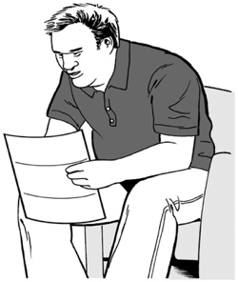
It does not matter if you did not get the information pack sent to you.

Some people choose to be on the unpublished electoral roll.

The unpublished electoral roll means that information about you like your address will not be published where other people might see it.

If you are already on the unpublished electoral roll you will need to fill in a paper enrolment form to change which electoral roll you are on.

Where to find more information

Our website has more information about:
- the Māori Electoral Option
- enrolling to vote.

The website address is:
vote.nz

You can also call us with any questions you have on:

0800 36 76 56
It will not cost you any money to call this number.

This information has been written by the Electoral Commission.

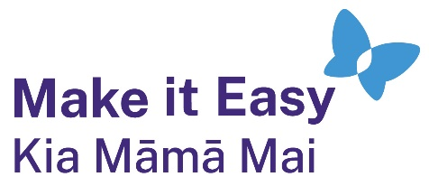
It has been translated into Easy Read by the Make it Easy Kia Māmā Mai service of People First New Zealand Ngā Tāngata Tuatahi.
The ideas in this document are not the ideas of People First New Zealand Ngā Tāngata Tuatahi.

Make it Easy uses images from:

- Changepeople.org

            - Photosymbols.com

- SGC Image Works
- Huriana Kopeke-Te Aho
- T. Wood.
All images used in this Easy Read document are subject to copyright rules and cannot be used without permission.

